Step 3
The company I was assigned to was IAG Group.
When I found out this company was an airplane company, I was so excited because I once wrote a report about British Airways in the past! But the topic was different. The last report was about the customer services while this one is about my analysis, understanding, and engagement of the annual report. And because this is my first term in this school, which means I did not take the ACCT11059 in the last term, so here in this report, I will compare IAG group with British Airways instead.
The first thing I did was to check the annual report of the IAG group to make sure the balance sheet, the depreciation and inventory accounts were included in the annual reports of the last three years. The answer is a reassuring “YES"! I was so relieved because I want to write something about Airplane Company and of course, a better comparison would be made because they are in the same business area.
To do so, I downloaded the annual report of British Airways especially. Let’s leave aside the annual report for a moment, from the perspective of the official website, I prefer the one of British Airways because and the colour of webpage is more attractive (IAG's webpage is basically grey), and there are more pictures and detailed information about the tickets, the flights and the services they provide. And the words they used on the website were more guided since I did have to google the title of IAG’s annual report to find where they were. I think a well-designed webpage is a necessity for a company because it works like a guide as well as an attraction for its customers. If people like the design of a webpage and can easily find the information they want, they will spend more time browsing the web. As a result, the number of orders is likely to increase.
About the company
In order to better understand the company, I did some search for the background of the two companies. And the web pages, which introduced the background, were full of surprises! First I found out that IAG was not a company, it was a "group." It was formed by the merger of British Airways and Spanish airways. That's right. The British Airways I was talking about! I really could not believe my eyes! It was so incredible! (I almost screamed out in the library!) The company was incorporated in Spain in January 2011 and is now headquartered in London, UK. Since British Airways was a big company, it invested 55% of the total shares when it was founded. According to IAG, it was listed on the London stock exchange within a month of its founding, as well as the Spanish Stock Exchange in the following couple of months. It has been a constituent of the FTSE 100 since January 24, 2011, and has been part of the IBEX 35 index since April in the same year. Today, IAG is Europe's third-largest airline company and the sixth-largest in the whole world. They have 546 planes and 279 routes in total with an average 105 million passenger volume per year. (IAG Group, 2016) I became speechless and was attracted by this company after reading its background. It is unbelievable! It's hard to imagine how a company which has been set up for only seven years could achieve such a huge success! All the information made me even more excited, and I could not wait to explore more about the company!
About the annual reports
I was fascinated by the performance of the company. In the past few years, the company has experienced steady and rapid development. The operating profit had a significant six-fold increase from €485m to €3015m in the past six years, which was so incredible! Especially over the past three years (from 2015 to 2017), the company has demonstrated strong operating capabilities, both concerning profitability and company scale. I made two figures to show the overall performance of the company in the last three years:
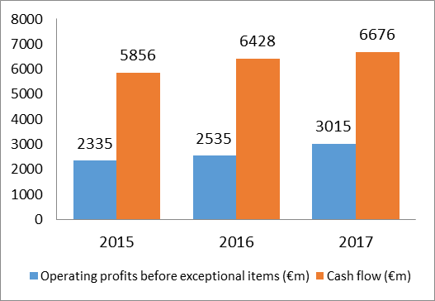
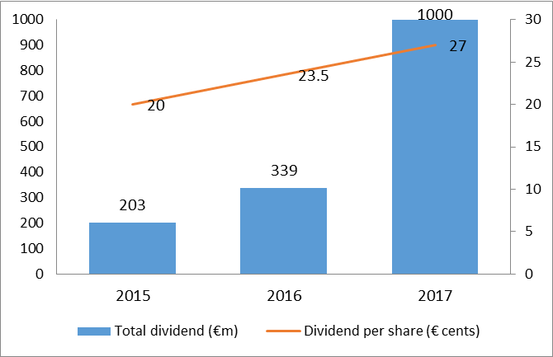
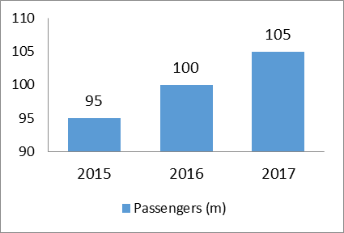
Here are two points about the figures that surprised me. The first was the increase of the total dividend of from 2016 to 2017. I could not believe that they gave out €1 bm for its shareholders in total in 2017, which was more than twice of the one in 2016! The second was the growth rate of the number of customers. As shown in the figure, IAG's customer base has grown by 5 million a year over the past three years. So incredible!
Concerning the purpose of the company, the following are some quotes from Chief Executive Officers
"We have the ambition, and we have the plan to deliver the best value-for-money experience for all of our customers.”, said by Alex Cruz, the Chairman and Chief Executive Officer of British Airways.
“One of the key pillars of the Plan de Futuro is our full transformation of Iberia’s customer proposition, putting the customer in the centre of all our activities.” said by Luis Gallego Martín, Chairman and Chief Executive Officer of Iberia.
“Vueling’s key strategic levers for the future are customer focus, operational excellence, and profitability.” Said by Javier Sanchez-Prieto, Chief Executive Officer of Vueling.
From the data and quotes, I've learned that there are three concepts the company has given focus on sustainability, profitability, and customer. It reminded me of what I had learned in marketing and customer service. In my opinion, the three are interrelated, and the most important of the three is "customer priority." The quality of service largely determines a company's profitability. For example, two restaurants make food with the same taste and cost. However, the waiters in one restaurant have a poor attitude and slow serving speed, while the ones in another restaurant always work with a smile and serve food very quickly. Then I will choose the second one and go there often. I think most people would have the same choice as me. Because quick, convenience and pleasant are always attractive. Airlines themselves are service industries, so improving customer flight experience is extremely important. Things could be big like flight punctuality rate or small like the sanitary condition of toilets.
Because I once learned that "repeat customers" are crucial for the long-term stable development of a company. If a customer is satisfied with the company's customer service, he will choose the company's service again and might recommend the company to his relatives or friends. As a result, the company's customer base will be larger; thus the possibility of increasing revenue will be higher. As the income increases, more investment will be attracted, which would lead to the better customer service level. As I wrote in STEP 2, this is a loop. And In my opinion, improving service quality is the beginning of this cycle and also an outstanding opportunity for future development. After I wrote this all down, I immediately went and searched for news and videos. Here are some links showing the opportunities to develop by increasing customer service.
Opportunities:
https://www.youtube.com/watch?v=yJIX12jPdUg https://www.youtube.com/watch?v=20vJKW_RN6w https://www.bbc.com/news/technology-37848554 https://www.bbc.com/news/business-43739254
However, the company is facing challenges too. I found the IAG officer's statement on its official website while I was searching for the news. In this statement, he claimed that the high fuel oil prices and a slowdown in the global economy were not only the challenge the companies were facing, but the issues with environment had become more and more serious. (IAG Group, 2012)
Challenge：
https://www.youtube.com/watch?v=rDWal-72n40 http://www.iairgroup.com/phoenix.zhtml?c=240949&p=irol-newsArticle&ID=1707185
IAG annual reports
http://www.iairgroup.com/phoenix.zhtml?c=240949&p=irol-reportsannual
Here is the link to my blog:
http://mingxin1307music.wordpress.com
All in all, it was an enjoyable process for me to complete the whole STEP 3, which was also full of challenges. Especially for the analysis and understanding of the annual report, it took me a long time to connect all the knowledge points and give my understanding and analysis.

Reference
IAG Group. (2012, 6 21). News Release. Retrieved 2018, from IAG International Airline Group: http://www.iairgroup.com/phoenix.zhtml?c=240949&p=irol-newsArticle&ID=1707185
IAG Group. (2015). IAG_AnnualReport2015_160302.
IAG Group. (2016). About US. Retrieved 2018, from IAG International Airline Group: http://www.iairgroup.com/phoenix.zhtml?c=240949&p=aboutoverview
IAG Group. (2016). Annual report and accounts 2016.
IAG Group. (2017). Annual_report_and_accounts2017.

Step 4
I finally got a chance to get my hands on the report again! I was so happy! To tell the truth, what I like most in accounting is to complete the statements. Because it is simple, I need to write some numbers and don't need to write so many words. And only through these numbers can reflect the financial situation or performance of a unit or individual in a period. As I once said, this was the reason why I like accounting. I have also used EXCEL to make statements in the past, so it was not new for me. I have some understanding of the use of EXCEL. Therefore, I have been looking forward to making statements with EXCEL! The following are my answers to the questions, which also include my thoughts, feelings, as well as confusion in the process of making the statement.
Question A &B
When I first opened the sheet, I found that I did not know what charts of account meant. Then I looked at all the items in the table carefully and then gradually understood the meaning of them. And I found that some items in this example were not suitable for my situation. At first, I tried to modify the original table but found that it was not very convenient. So I just rebuilt an EXCEL and made a new sheet just like the example. In my own words, to make the whole sheet, the first step was to list all my transaction items in chronological order, which were listed in the column of Transaction Details. Then, I classified these items, such as salary income, general living expenses and so on, and wrote them after each transaction in the column of "category of my chart of accounts." Finally, items in this column would be reclassified by income, expenses, assets, liabilities or equities, and are listed separately beside the entire table. I think the whole table was amazing! In this simple table, I could not only see the date, amount and object of each transaction but also clearly saw the types each transaction belongs to.
Here is my chart of accounts
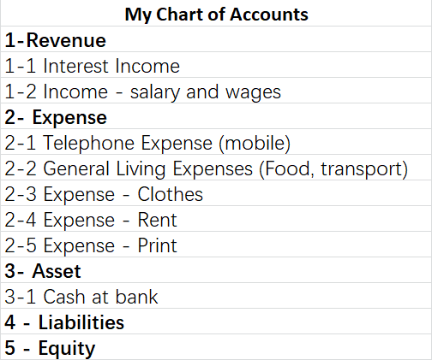
In fact, in the beginning, I was worried about whether it would take me a long time to complete this new form, but I found that my worry was completely unnecessary! Excel is a powerful piece of software. To copy the same terms, you just need to use "=," and the calculation was just as simple. It only took me about fifteen minutes to redo the whole table. The process made me suddenly think of what my lecturer said in class. He says paper and pen used to be very inefficient in keeping accounts. But now the technology has been more and more developed, the software can help us save a lot of time. If you still spend much time using the software, then you must NOT use the software well. This also reminds me of what has been mentioned in Chapter One. Although the software is used for accounting now, the theory is still the same.
As for the adjustment of the items, in the income column, I did not change anything because these two items also happen to be the sources of my income. In the column of expenses, I removed the original fuel and insurance costs and replaced them with the cost of clothes, printing, and rent, and kept the telephone and living expenses. I didn't change anything about the rest.
Question C
I really enjoyed analysing my income statement. This was my first time to see my consumption and income in a month intuitively. I have never analysed my consumption and income before. If I had not done this chart, I would not have known that I spent more than I earned last month! However, of all the expenses, the two major ones were rent and living expenses (52.1% and 42.2% of total consumption respectively), while the living expenses account for the main part of Coles. I thought these were the expenses that I had to pay for my life. Apart from these two items, other consumption was not too high. So, if I want my income to exceed my expenses, I need more work! Once again, I think it was an excellent decision for me to make this form by myself! This process made me remember every knowledge point more firmly and had a deeper understanding of each, which was of great help to me. Not only did I now know precisely what cart of accounts was, but I also knew exactly how to calculate each item. Especially for the percentage numbers in the Income statement, which meant "what percentage of the total Income is XXX." They visually represented the percentage of total income of each item, reflect the structure of my income and consumption and tell me what problems exist in my consumption pattern.
Question D
There was one point that I hesitated about when writing this form, which was, I spent $150 on a 6-month SIM in October, but I knew this was a prepaid expense, which means that I have not got the corresponding 6-month service yet. Therefore, I thought for a long time about it. Under the accrual basis, this $150 should be divided by 6 (which turn out to be $25 per month). But if I follow the cash basis, $150 should be recorded in this month. Actually, I was not particularly sure whether the record of $25 was correct. However, in accrual basis, accounts are recorded according to the time of occurrence rather than the time of collection or payment. And this is the most significant difference between accrual basis and cash basis.

Step 5
This step was beneficial to me! And it was a big challenge! Without Martin's help, I indeed could not have finished the task successfully. I thought it was necessary to record this whole process.
At the very beginning, I thought this task should be relatively simple, which was to paste the data in my company's annual report into this trial balance in order of different types. However, after I finished pasting them all for the first time, I found that there was an imbalance between credit and debit. I felt very strange and checked again whether all items were classified correctly and whether the data were accurate. After the quick check, I found that all the items were classified correctly, and the data were not pasted incorrectly, but the left and right sides were still unbalanced. So I turned to Martin for help. After reading my trial balance, he found that the left and right columns of my balance sheet were balanced, which indicated that the data presented here were correct. That meant, therefore, the problem was in the income statement. So he began to check the income statement and found that my income and expenses only included operating income and operating expense showed below:
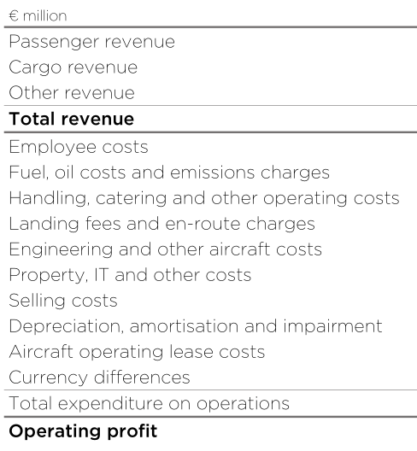
Besides, the following non-operating items should also be included in your income and expenses. (as shown in the figure below)
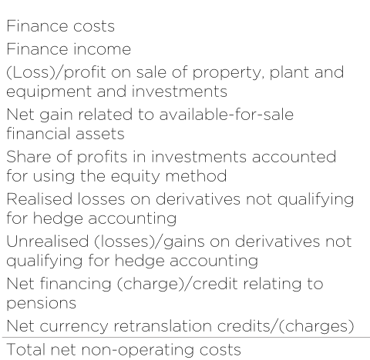
I have classified these items according to debit and credit. However, when I press "=," the two sides were still unbalanced! It was simply impossible! I have already included all the income and expenses, why were the left and right still unbalanced?
So I asked Martin to help me again. He was very strange at first, very strange. So I checked all the data in the Income statement again with him, and we found that there was no problem at all. I told him that I have checked that in addition to comprehensive income, the total income minus the total expenditure was equal to €2012m, the same as the profit after tax showed in the annual report. However, why were the left and right sides still unbalanced?
After a short think, he first deleted the comprehensive income account, then added a Profit, and wrote "2021" in the debit column of the income statement. Guess what? They balanced! You cannot even imagine my face! "OMG, it is impossible! How could you do it?" I shout out loud in the class! I could understand why he has added profit, which I did not expect because profit was also counted as part of the company's annual income. But why did he write 2021 in the debit column? Profit was income; shouldn't it be written in the credit column? He laughed and explained, "The only way to balance trail balance is to balance both your income statement and balance sheet. But the income statement itself does not need to be balanced. You see that the income is €2021m more than the expense, so the only way to balance it is to add 2021 to the debit column to make both sides balance.” I suddenly realized! It was amazing! It made me more obsessed with accounting! Also, Martin was such a wise man!
I then asked him, "Why all the income and expenses were divided into two parts?" "This shows the rigor and accuracy of true accounting," he says. "Total revenue and expenses are related to the operation, while part of the latter is unrelated to operation. The purpose of this separation is to present a clearer picture of a company's performance and capabilities.
After listening to his explanation, I really admire the rigor of accounting. By completing this trial balance, I also learned much knowledge that I did not know before. It was an enjoyable and challenging experience!

