Before getting started, I would like to say that from the chapter of inventory, the whole learning process started to become difficult. In the past, I could totally understand the class and remember the points easily. But from this chapter it became harder to follow Martin in class. There were more information in one class and the contents were new for me and much deeper than before. Sometimes I went back to the study guide and the lecture slices many times and still got confused. So I used Google or YouTube to help me and fortunately, they did helped a lot.
Step 7
To start with, I went directly to the annual reports for the last three years of my company, the IAG Company. I searched for the word “inventory” and “inventories” in the three reports respectively, and I easily found this account in the balance sheets. It was quite comforting because I did not have to change the company for this step and I did not want it either. However, I got a bit disappointed because there was not much information directly showed up with the word “inventory” or “inventories”. Anyway, the first thing I did was to compare the figure in the balance sheet. And that was large! It showed that in the last three years, the inventories were €520m, €458m and €432m, which was $834m, $734m and $692m in 2015, 2016 and 2017 respectively. When I looked at these data, several questions came to my mind. Why the inventories kept going down in the last three years? As an Airline, what inventories could they have? And how do they manage and control such great amount of valuable inventories?
Carrying these questions, I first went to the notes. The notes for inventories were very simple. According to IAG, all the inventories were valued at the lower of cost and net realisable value, and such cost is determined by the weight average cost method. They did not change the valuation or calculation method in the last three years. Honestly, these two points were a bit confusing for me at first. I knew that the lower of cost or market value, or so called net realisable value, is the result of subtracting the cost associated with the final sale or disposal from the estimated selling price. But I did not understand why companies use this method. So I did some search and found that when the net realisable value is lower than the cost, it indicates that the future economic benefits brought by the inventories will be lower than its book value. If the companies still measure them at the historical cost, they are going to have an overstatement of assets and the profits would be not valid. This method conforms to the principle of prudence and validity, and reduces the possibility of manipulation of profits.
As for the methods for determining the cost, although I knew the theories and the ways of calculation, I still had many questions for this point. Why there are four methods? Why FIFO and weighted average are the most commonly used ones? And why LIFO is prohibited under IFRS? So I Googled again and fortunately, I got all the answers. Specific identification should be the best way because under this method every product is matched with the original price. But it could be not convenient when there are a huge amount of inventories and they are physically indistinguishable or easily substituted. Therefore, the weighted average method is then typically used in this situation. It is convenient as well. And for businesses which do not mostly carry expensive items or huge amounts of commodities, FIFO or LIFO then would be a good choice. Under a FIFO method, it is assumed that the oldest inventory is used first. So as a result, the ending inventory is valued at a cost closest to the current cost since prices tend increase over time. Also, the profit would be higher, as well as tax payable. The opposite situation explains the reasons why LIFO is prohibited under IFRS are that the tax payable would be lower and the cost of the inventories is impractical since the price would go up by time theoretically. Please excuse me that I went over everything again. Because I thought they were important for me to better understand inventory management.
Back to the topic. According to the company, the inventories are mostly aircraft expendables, including mainly aircraft spare parts, repairable aircraft engine parts and fuel. And when I kept searching key word “inventories”, I found something that was quite useful: the cost of inventories. It showed that the cost of inventories was €4899m, €3966m, €3176m in 2015, 2016 and 2017 respectively. That was so expensive! And it said that “Cost of inventories recognised as an expense, mainly fuel”. Now I know that the main inventory of airlines is fuel and understand why the company uses weighted average method --- because fuel is so physically indistinguishable and expensive. By the way, the annual reports did not mention the inventory recording system (perpetual or periodic) that they were using. But I think it should be perpetual because it is the commonly used on in business. And there were no words like raw materials, work in progress or finished goods because they are an airline company.
Another piece of information I found was the average fuel price in the last five years. The figure showed that the average fuel price had a decrease trend in the past five years, dropping by about $180 cents/US gallon from the peak of $314.15 in 2013 to the bottom of $133.38 in 2016. This explained the reason for both the decline in the value of inventories and the cost of them.
The company has fuel price risk management strategy to provide protection against sudden and sharp increases in fuel prices while ensuring that the group will not be at a competitive disadvantage when prices fall dramatically. According to IAG, the methods they are using to reduce the risk were buying oil derivatives and increasing the predictability of cash flow. The cost for the inventories, including derivatives purchase fees, warehouse rent, salaries for employees and so on, must be high. But I think it is worth it because on the one hand, fuel is the “core” and “life” for aircrafts. They could not work without fuel. On the other hand, fluctuations in the price of oil and petroleum products can have a significant impact on their business performance. The annual reports claimed that changes in fuel price could impact results before tax, as well as equity.
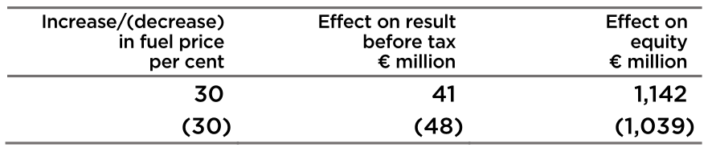
As for me, I never had any experience of storage before, but I do have a plan to open an online shop in the upcoming vacation. This step really provided me help and inspirations on inventory storage and calculation.

Step 8
It really took me a lot of time to figure out what was going on in this step. Firstly I thought I only had to watch the training videos. But after I read the requirement of Step 9, I suddenly found out that I had to follow the videos to work in the MYOB. However, although I spent more time, it was a helpful process to watch the videos twice. Now I was familiar with the software (at least I think so), and finally I finished all the screen shoots.
Screen shots of the training videos:
The starting screen shot of the first section: Starting out with AccountRight
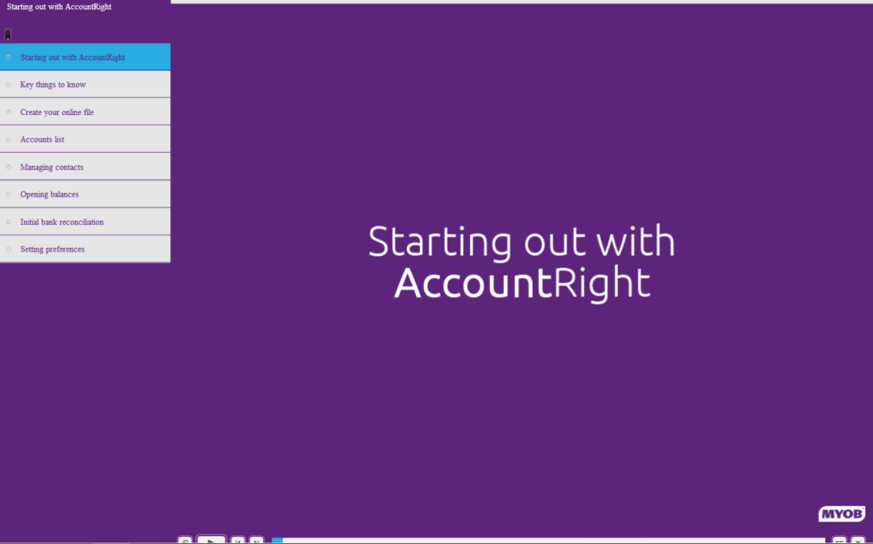
Screen shot of the last video of this section:
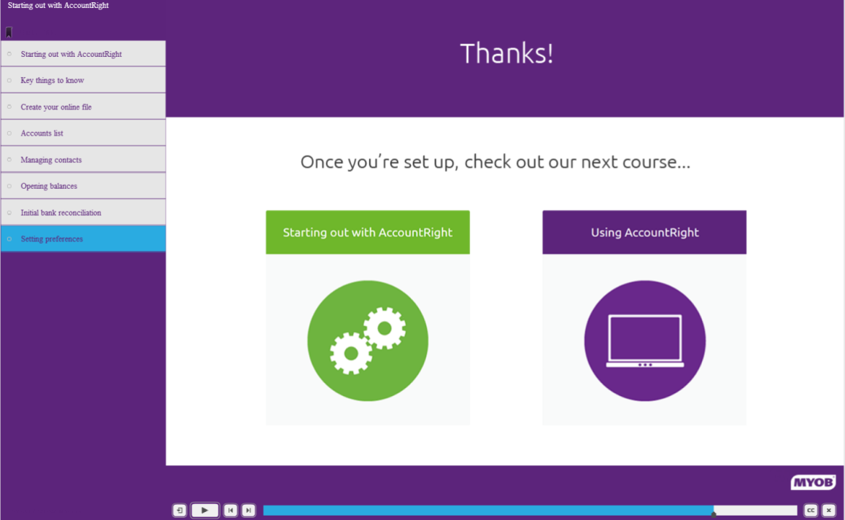
The starting screen shot of the second section: Using Account right
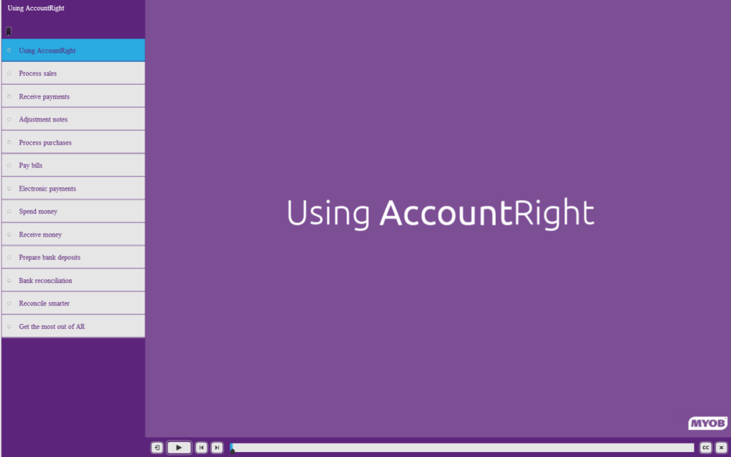
Screen shot of the last video in this section:


Screen shots of my MYOB:
My MYOB:
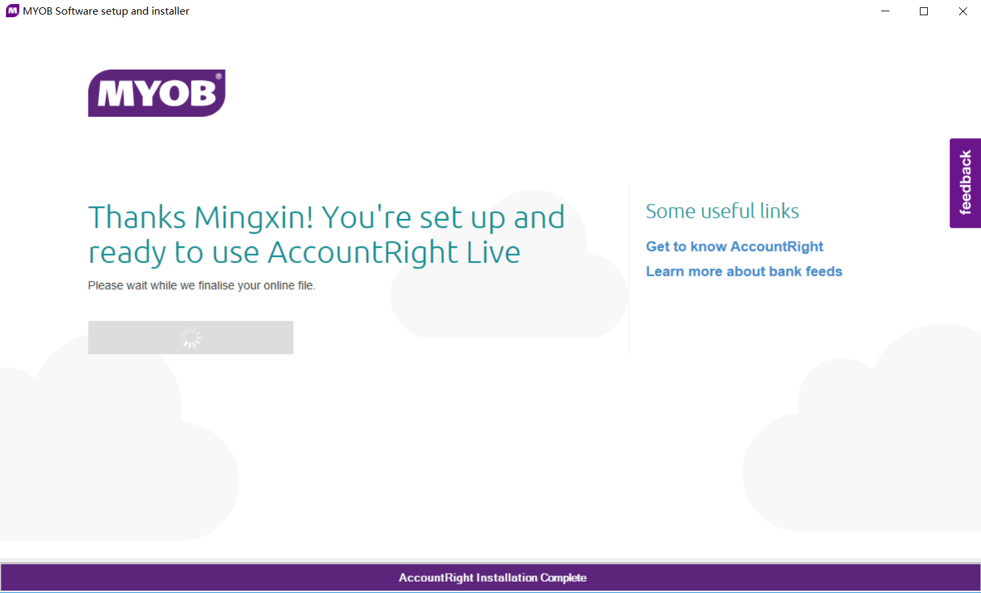
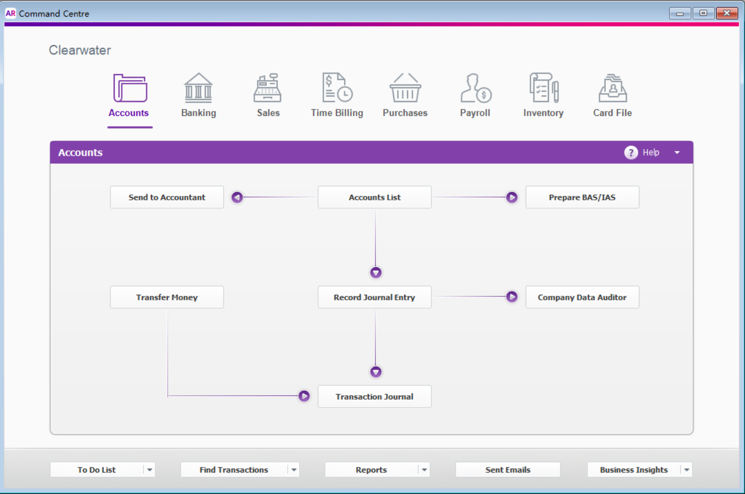

Last screen of the first training part (setting up):
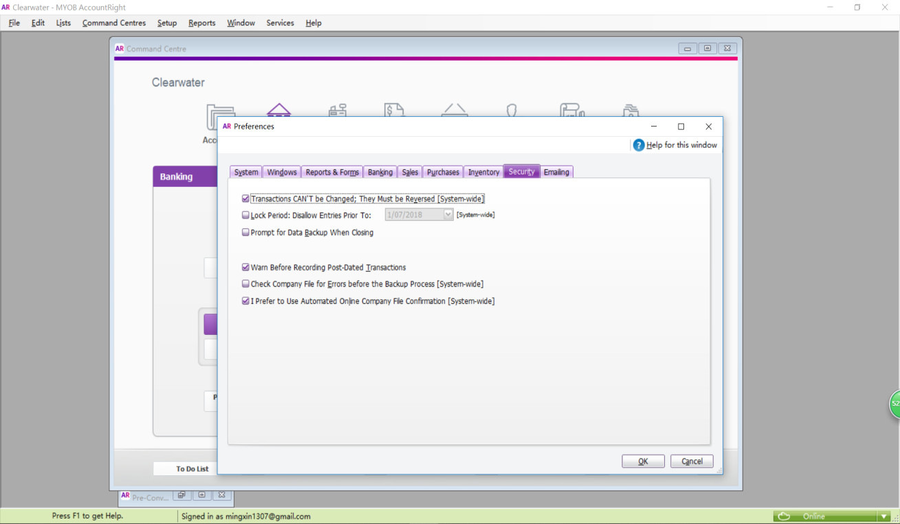
Last screen of the second training part (Using MYOB):
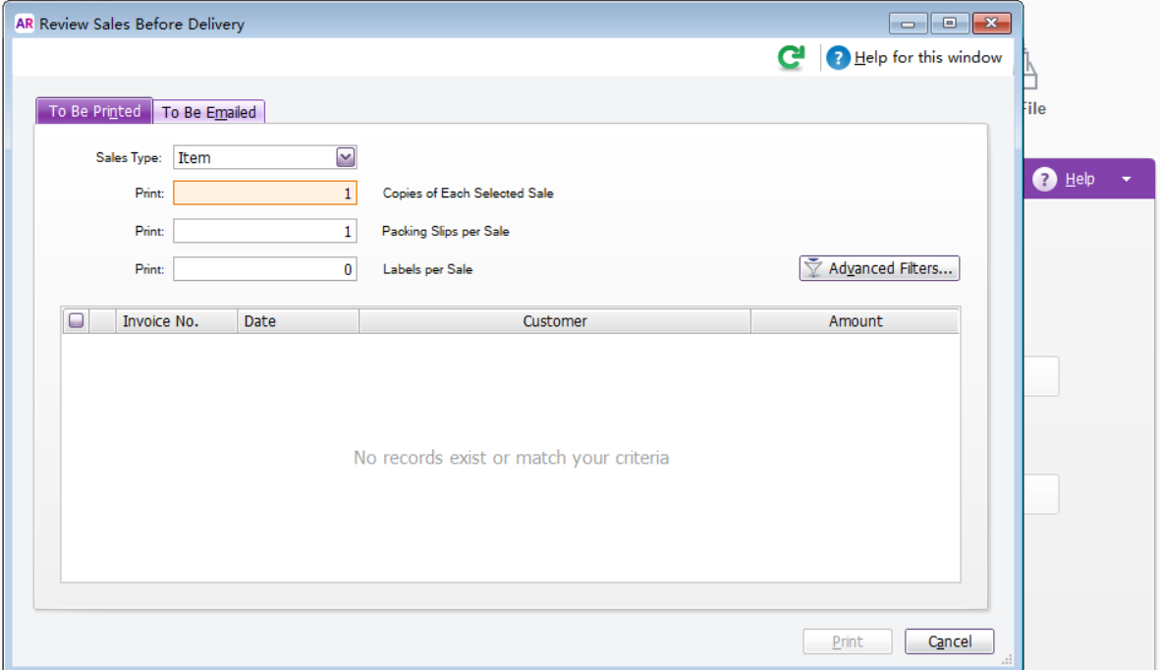(Because I did not set the “to be print” preference, so there is no records)

My training company file:
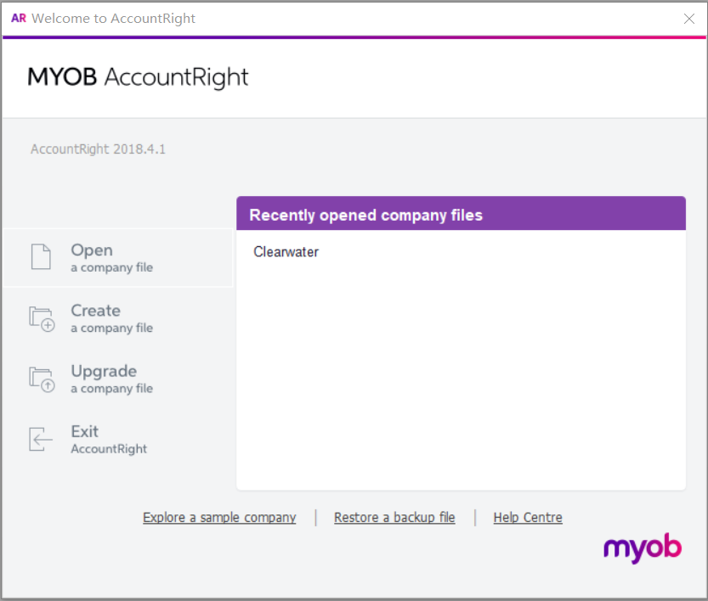
During the training, I found that there were already a lot of accounts in file video, which did not exist in my file. I was confused at first because without those accounts I could not follow the tutorial in the videos. Then I figured out it was because the time difference. The file in the video included the accounts in 2011 and 2012, while mine started from last year. In order to follow the tutorial, I created similar accounts for different categories, which made me more familiar with the software.
Here are the screen shots of my test:
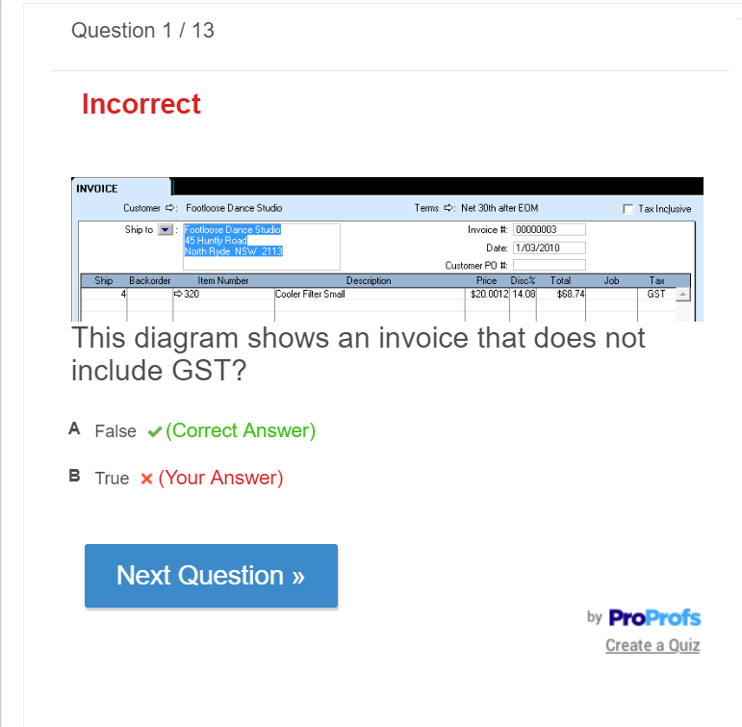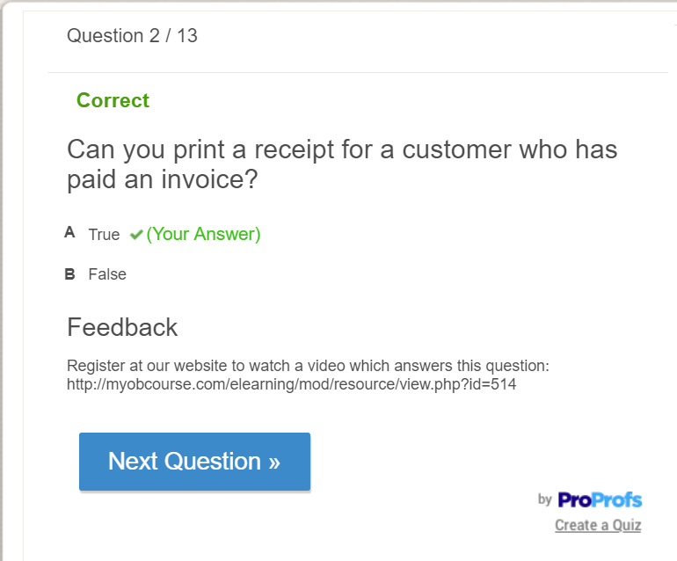
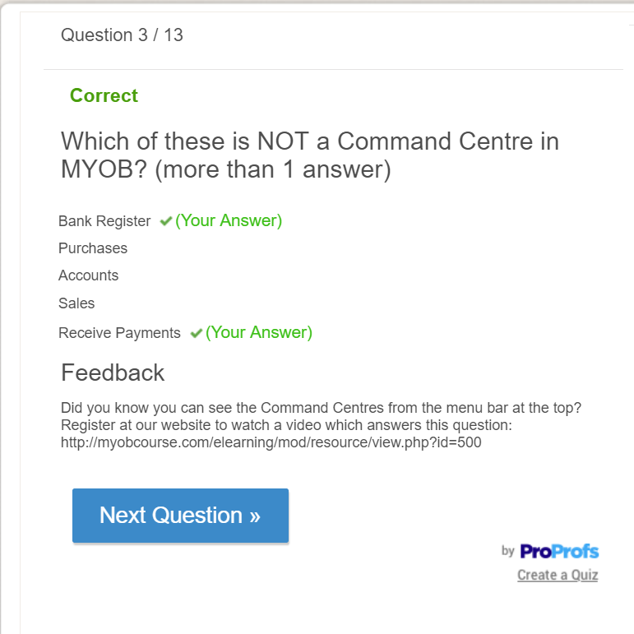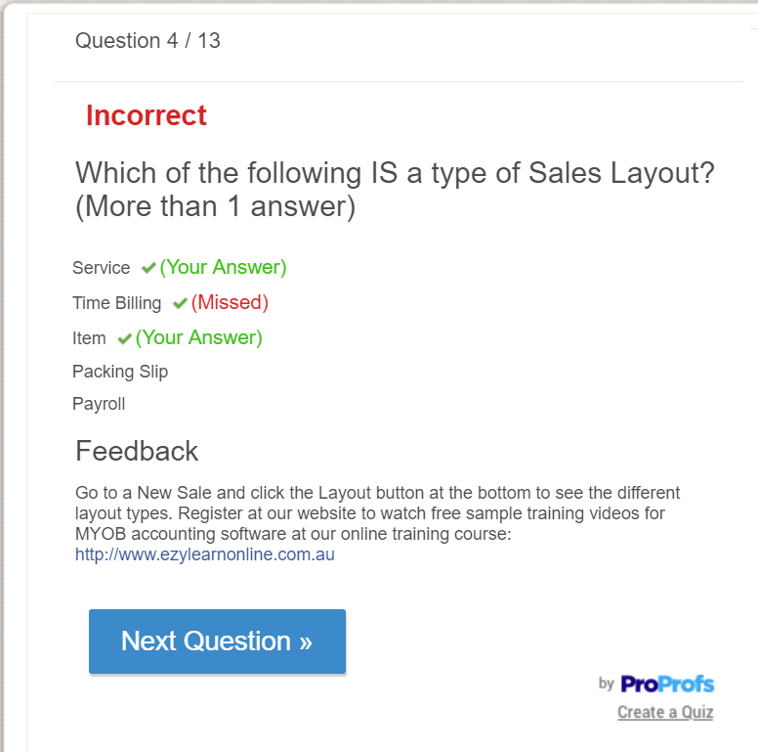
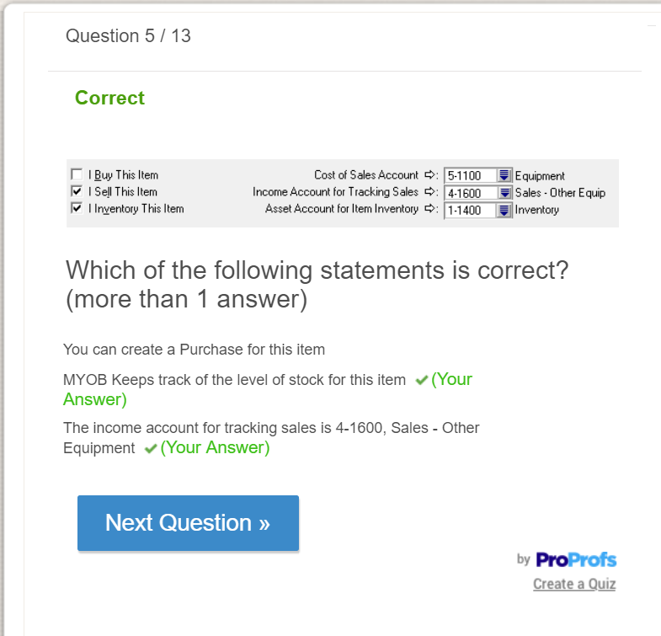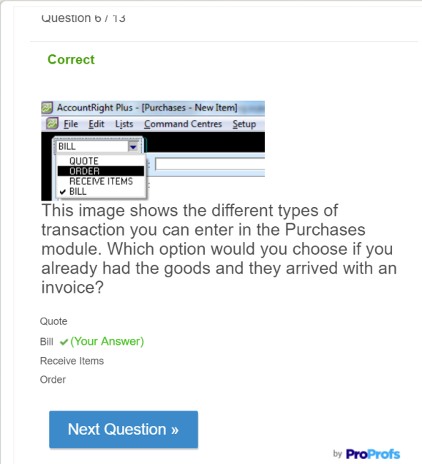
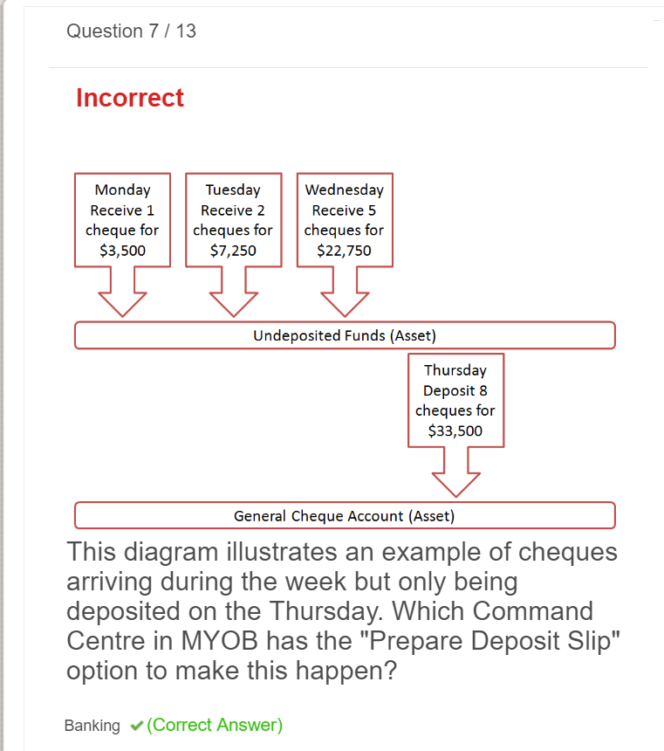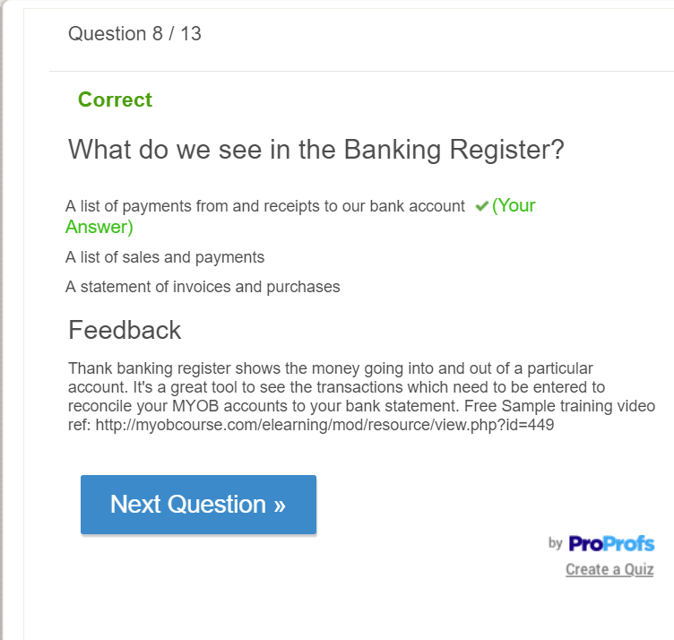
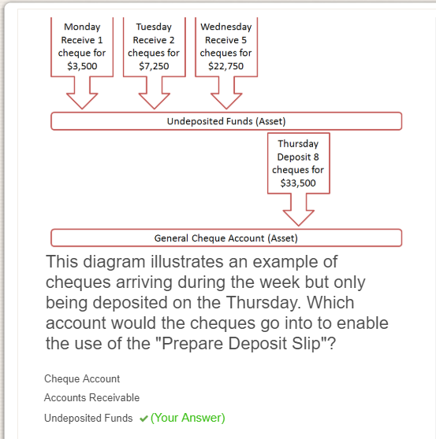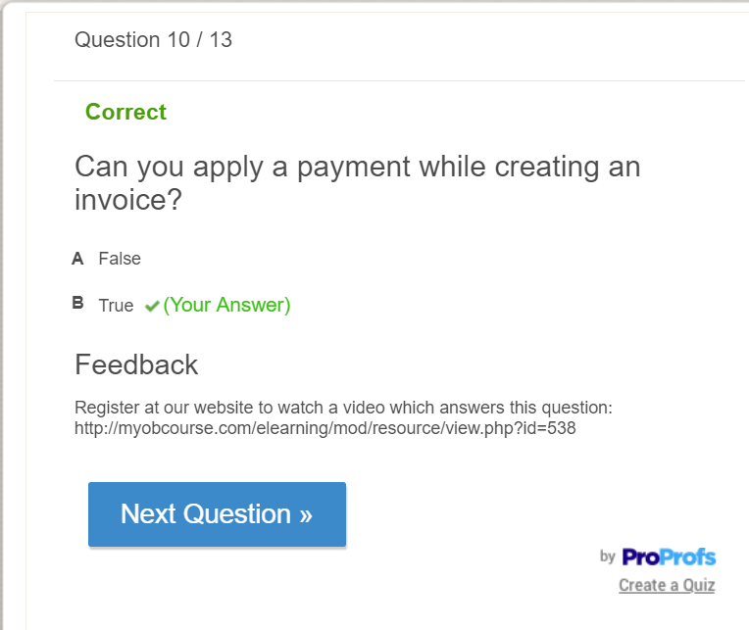
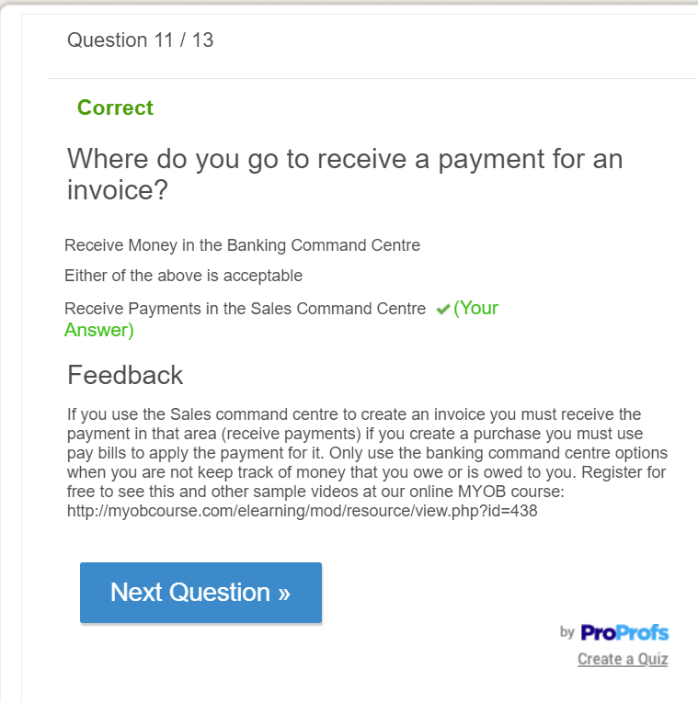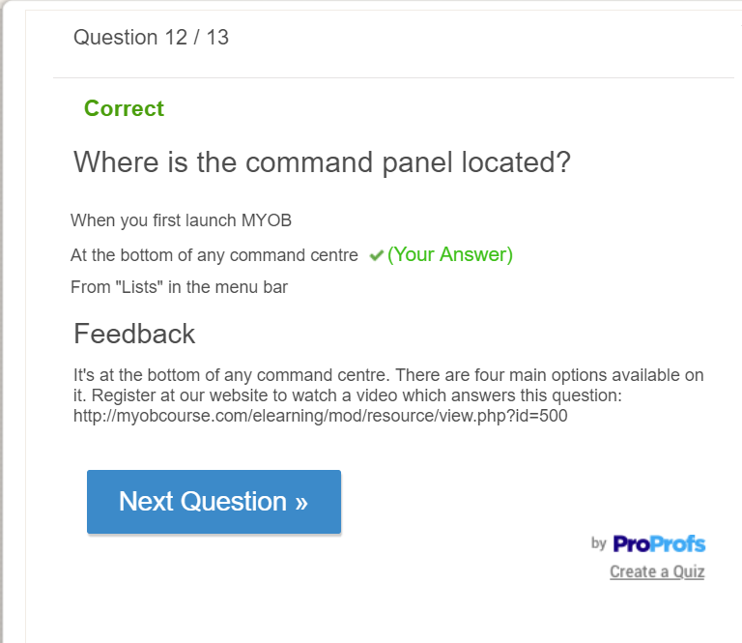
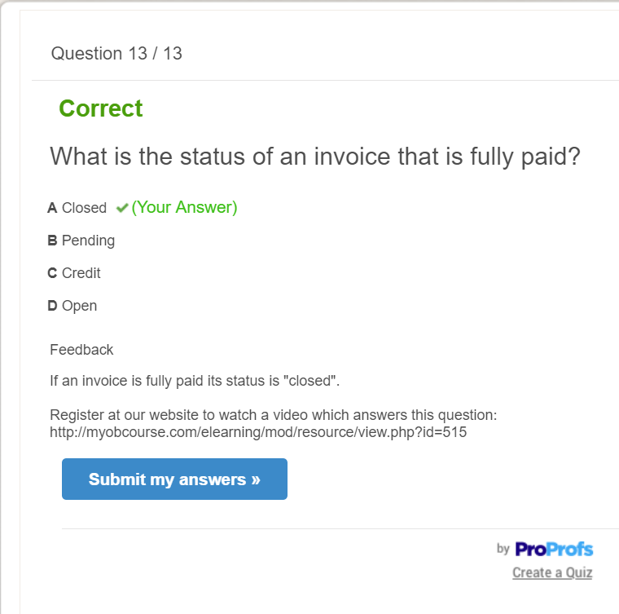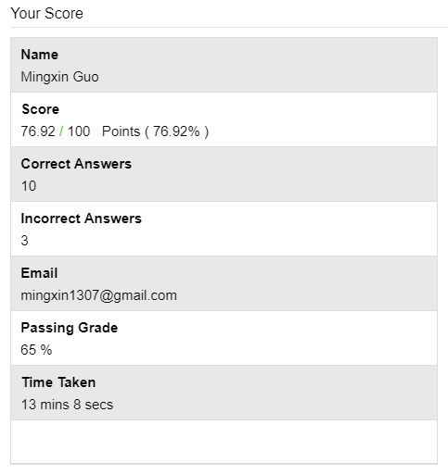

Step 9
Because this company is a global company, so the tax code must be different for different countries. Therefore, to make is simple, all the tax generated from in the following transactions will be assumed to apply to GST tax code.
Hypothetical transactions:
Date | No. | Transaction details
1/9/2018 | 1 | Fuel purchase | DR $990,000
1/9/2018 | 1 | Account payable | CR $900,000
1/9/2018 | 1 | GST paid | CR $90,000
1/9/2018 | 2 | Account receivable | DR $22,000
1/9/2018 | 2 | Sales from commercial flights | CR $20,000
1/9/2018 | 2 | GST Collected | CR $2,000
1/9/2018 | 3 | Account receivable | DR $11,880
1/9/2018 | 3 | Sales from freight flights | CR $10,800
1/9/2018 | 3 | GST Collected | CR $1,080
15/10/2018 | 4 | Maintenance Fees | DR $22,770
15/10/2018 | 4 | Cash and cash equivalents | CR $20,700
15/10/2018 | 4 | GST paid | CR $2,070
15/10/2018 | 5 | Account receivable | DR $21,538
15/10/2018 | 5 | Sales from commercial flights | CR $19,580
15/10/2018 | 5 | GST Collected | CR $1,958
15/10/2018 | 6 | Account receivable | DR $10,164
15/10/2018 | 6 | Sales from freight flights | CR $9,240
15/10/2018 | 6 | GST Collected | CR $924
23/11/2018 | 7 | Account receivable | DR $23,155
23/11/2018 | 7 | Sales from commercial flights | CR $21,050
23/11/2018 | 7 | GST Collected | CR $2,105
23/11/2018 | 8 | Account receivable | DR $11,121
23/11/2018 | 8 | Sales from freight flights | CR $10,110
23/11/2018 | 8 | GST Collected | CR $1,011
23/11/2018 | 9 | Salaries & Wages | DR $150,000
23/11/2018 | 9 | Cash and cash equivalents | CR $150,000
07/12/2018 | 10 | Account receivable | DR $19,822
07/12/2018 | 10 | Sales from commercial flights | CR $18,020
07/12/2018 | 10 | GST Collected | CR $1,802
07/12/2018 | 11 | Account receivable | DR $10,373
07/12/2018 | 11 | Sales from freight flights | CR $9,430
07/12/2018 | 11 | GST Collected | DR $943
07/12/2018 | 12 | Airport usage fee | DR $16,500
07/12/2018 | 12 | Cash and cash equivalents | CR $15,000
07/12/2018 | 12 | GST paid | CR $1,500
17/01/2019 | 13 | Account receivable | DR $21,780
17/01/2019 | 13 | Sales from commercial flights | CR $19,800
17/01/2019 | 13 | GST Collected | CR $1,980
17/01/2019 | 14 | Account receivable | DR $10,340
17/01/2019 | 14 | Sales from freight flights | CR $9,400
17/01/2019 | 14 | GST Collected | DR $940
17/01/2019 | 15 | Aircraft parts purchase | DR $381,480
17/01/2019 | 15 | Account payable | CR $346,800
17/01/2019 | 15 | GST Paid | CR $34,680

Screen shots of different reports:
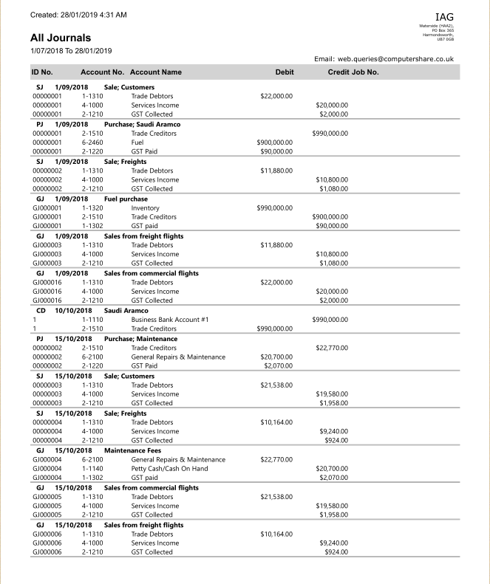
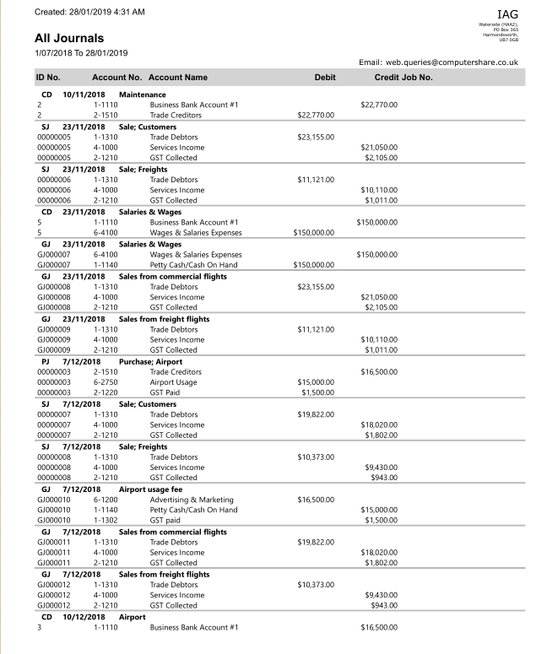

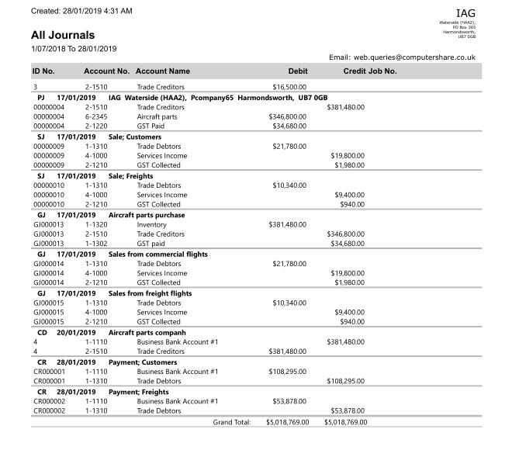
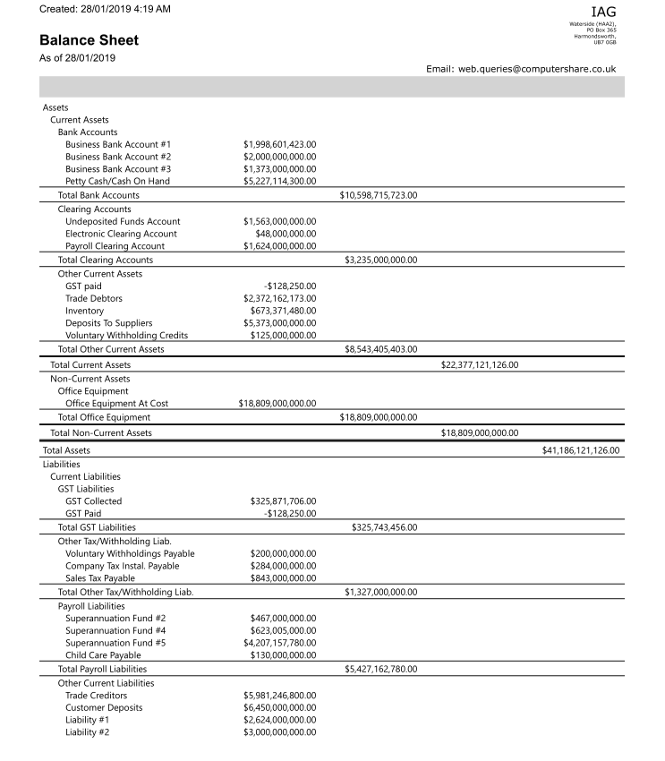
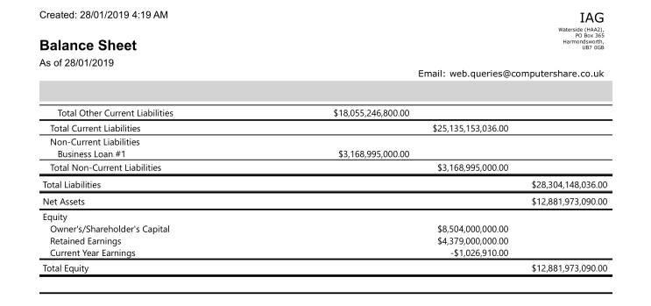
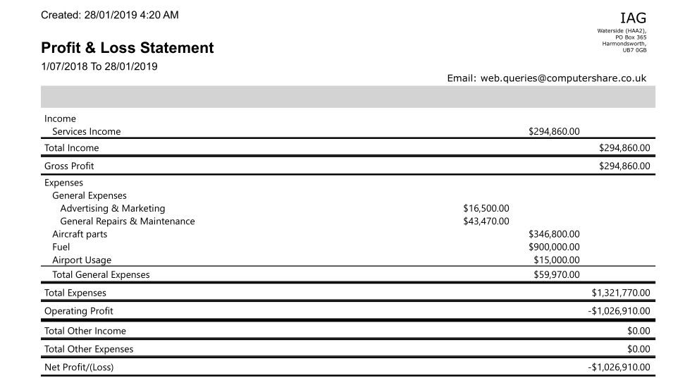
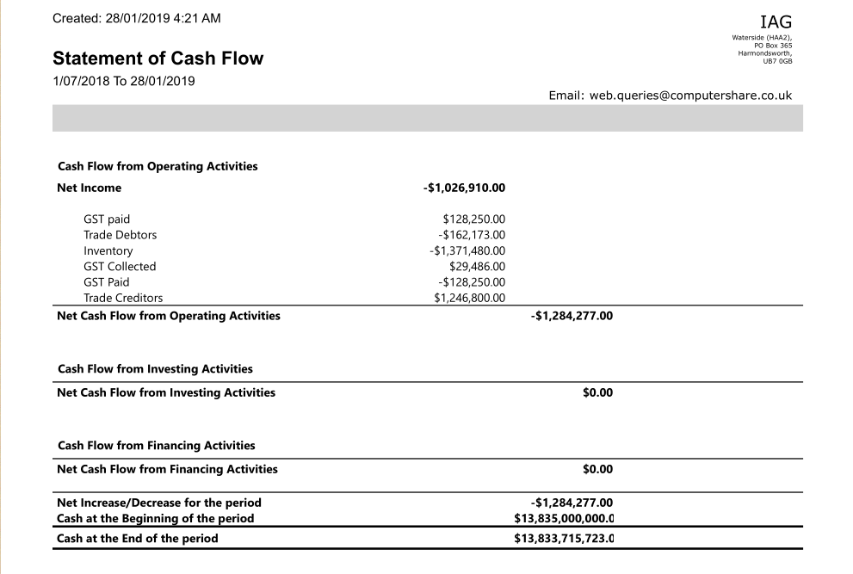
It was a hard job to create and record all the entries. Firstly I had to create reasonable transactions for an airline company. For an airline, passenger and cargo flights are the airlines' main sources of revenue. Fuel costs, aircraft maintenance costs, staff costs and airport use fees are the airlines' biggest operating expenses. So I tried to cover all of them in the transactions. And while recording the journal entries, I found a little mistake in the system. In the system, “GST paid”, which should be treated as an asset, was treated as a liability. I did not thought about this mistake when I recorded the first (or first two) entries. But after that I started to realise it was wrong so I created a new asset account for it and modified the journals I imported earlier. And another question that I had during the recording was that I tried to separate GST Paid or Collected from the total amount, however, it worked oddly when I selected the “Tax Inclusive”. The results never turned out the ones that I wanted. Therefore at last I did not select this option and imported the GST manually. The journals looks fine but I am not sure whether this method is right. (I really tried!) And I really appreciated the Examplers in MOODLE. They helped to find the All Journal report.
And the process of generating the balance sheet, income statement and the statement of cash flow was much more complicated than I expected. When I finished recording the journals, I tried to generate them from the “Report” centre. However, I found the income statement and the statement of cash flow were blank. Then I suddenly realised that the sales and purchases have not been recorded yet! That must be the reason for the blank sheets. OMG More work to do! …Then I started to create sale and purchase entries, and I paid and received all the outstanding bills for the suppliers and from the customers respectively. Oh I forget to mention that I recorded the opening balance, customer balance and supplier balance before getting started of everything. That was how I could get my balance sheet.
Analysing financial statements
Because all the transactions above were based on hypothesis, the statements above are not correct. For this reason, I would analyse the statements in the annual report of 2017.
Before getting started I want to say that those numbers (in the statement) were very…. large. It is truly a big company. The revenue generated from operating activities was € 22972m, almost 88% (€20245m) of which came from the passengers. As I mentioned before, flights is the main source of revenue, especially commercial ones. Employee cost and fuel cost were two main expenses for the company (€4,988 m and €4,610 m), which account for 24% of the total cost respectively. I did not expect the cost for employees would even be higher than the cost of fuel. It seems that there really are a lot of people working there.
There were €1,494m receivables remained outstanding at the end of 2017, accounting for about 8% of total revenue. For me it is an acceptable number. And there were €3,766m outstanding payables, accounting for almost 40% of the total current liabilities. At this point, I decided to use the following ratios for further analysis.
Current ratio
I decide to use this formula is because the outstanding account payables. The current ratio of IAG in 2017 was 1.054. Generally, the current ratio is expected to be higher than 1. And the higher the current ratio, the more capable the company is of paying its obligations because it has a larger proportion of short-term asset value relative to the value of its short-term liabilities. Therefore, the company had a healthy liquidity, but I thought it could be better if this ratio is higher.
Return on asset
I also want to know how effective the company is in converting the money it invests into net income. The ROA of IAG was 7.4% in 2017, which was a good sign because ROAs over 5% are generally considered good. And the higher the ROA number, the better, because the company is earning more money on less investment.
The company had a strong cash flow in 2017 (€6,676m). I thought cash flow would not be a big problem for airline because they sales tickets every day.
In general, no matter the financial statements or the financial performance presented to be healthy and developmental trend. One effective way of growing profit would be fuel price hedging which could reduce or eliminates a company's exposure to fluctuating fuel costs.

Step 10
I was always told that depreciation is a difficult part to learn. Martin said that there was a whole book just for depreciation. (Hard to imagine!) But the good thing is that I learned about depreciation before, so for me it was not so unfamiliar. I could follow most of the lecture in the class, but there were still new things for me and I want to cover them in this step for better understanding.
When I opened the annual reports and searched for “depreciation” and I found many related information for this term. Firstly I gave a quick look of the account showed up in the income statements of the three years. The name of this account was “Depreciation, amortisation and impairment”, which remained me of a new point that I learned in this section. I did not know that for different kinds of assets the name of depreciation is not the same: depreciation is only for tangible assets such as plant and equipment. And for intangible assets, which are not physical in nature (such as patents, trademarks and copyrights), the depreciation should be called amortisation. And because intangible assets are usually not considered to have any residual value, the full amount of the asset will be typically amortized. But I am wondering that how could something like copyrights depreciate? Why would copyright lose value as time goes by? (I tried to search online but I did not get any answer) Besides, impairment refers to the sale or abandonment of assets that no longer benefit the company, that is, future cash flow it would generate if it continued to work (fair market value) is estimated to be less than the carrying value (written down value). And impaired assets must be recognized as a loss on the company’s income statement. For me I think is a wise practice ---- only keep assets that would be beneficial to the company.
Back to the figure, the depreciation, amortisation and impairment was €1,307m €1,287m €1,184m in 2015, 2016, 2017 respectively. Again, going down. So the same question showed up in my mind: Why? So I continued to look for information about depreciation, and another question appeared before I found the answer for the first one. In the cash flow statement, there was also an account called Depreciation, amortisation and impairment. But I remember that depreciation is not a real expense, it was just a book entry. So why did it show up here?
Then I went down to the policies for depreciation, amortisation and impairment. Let me list the policies first.
- Straight-line method is used for depreciation calculating for all kinds of tangible assets. (Calculated to write off the cost less the estimated residual value over the economic life of the asset.)
- Asset value is calculated under cost model (not revaluation model).
- All aircrafts are used at fair value after taking into account the manufacturer's credit line. According to the aircraft fleet plan of the group, the depreciation rate is determined according to the type of aircraft. The overall parameters of the depreciation rate are: the useful life of shorthaul aircraft is 23 years and the residual value is 5%; for longhaul aircrafts the useful life is 25 years and the residual value of 5%.
- Property is depreciated over its expected useful life over periods not exceeding 50 years
- Equipment is depreciated over periods ranging from 4 to 20 years.
- Assets that have an indefinite useful life are not subject to amortisation and are tested annually for impairment.
I was surprised that they used straight-line method and cost model for depreciation calculating from the very beginning, since I thought that accumulated method and revaluation model were more common. Anyway, assets will depreciate same total charge at last. Maybe they just wanted to make things easier because firstly, by using straight-line method, the calculation would be much simpler and the profit would seem not to be affected by using this as the deprecation amount was the same every year. If accumulated method is used, the profit would be the lowest for the first year of depreciation and start to increase afterwards. Besides, there was no need to adjust the value of the assets under cost model, only impairment. But I thought maybe revaluation model would be better because the value of assets always changes, therefore the data would be more valid with a better reference value.
This made me even more confused. How could deprecation keep decreasing under straight-line method? It should be the same theoretically. But suddenly I realised that it might because of the impairment. Then I went for the Property, plant and equipment account in the balance sheet and gotcha! The amount of property, plant and equipment was €13,730m, €12,227m and €11,846m in 2015, 2016 and 2017 respectively. That must be the one of the reasons for the decreasing trend of depreciation. So what changed? I then went down to another note called Depreciation, amortisation and impairment of non-current assets. It showed that the most significant decrease in depreciation was from owned assets. (From €834m to €739m then to €641m) This told me that the assets they owned were decreasing. And I found evidence from cash flow statement as well. It showed that they sold out €1,737m property, plant and equipment and intangible assets in 2016, almost 6 times larger than the amount in 2015 and 2017. They did it for helping them to come through the financial crisis in 2016. They also impaired €14m intangible assets in 2016 due to the same reason.
And the reason for why the deprecation account showed up in the cash flow statement might be that because depreciation is a book entry, not a real expense, which means that the real cash flow will not be affected. However they did record depreciation in expense, so they should add up the amount in the cash flow statement for the expense. By the way, depreciation is a good way to show the “really value” of an asset. As time goes by, the working efficiency would decrease due to different reasons (including wear and tear, Age and expected usage, Technical and commercial obsolescence and Legal or similar limits), thus leading to drop in the ability of benefit generating.
Journal entries
And here are the three hypothetical deprecation journal entries for the company:
As they used straight-line method, I need the following three pieces of information for creating journal entries:
- historical cost
- useful life
- residual value (how much is it worth at the end of useful life)
Suppose that they purchases 20 shorthaul aircrafts worth €100,000 in 2016 with 23 years’ useful life. The residual value is 5%. Therefore, the depreciation amount for each year is:
(100,000-100,000*5%)/23=€4130.43
The depreciation journal entries for the following three years would be:
General journal
 |  | DR | CR
Jun 30 2017 | Depreciation Expense | €4,130.43
Jun 30 2017 | Accumulated Expense shorthaul aircrafts |  | €4,130.43
Jun 30 2018 | Depreciation Expense | €4,130.43
Jun 30 2018 | Accumulated Expense shorthaul aircrafts |  | €4,130.43
Jun 30 2019 | Depreciation Expense | €4,130.43
Jun 30 2019 | Accumulated Expense shorthaul aircrafts |  | €4,130.43

The amount for the aircrafts for the three years would be:
Written-Down Value
2017 | €95,869.57 (€100,000 - €4,130.43)
2018 | €91,739.14 (€95,869.57- €4,130.43)
2019 | €87608.71 (€91,739.14- €4,130.43)

Because they use straight-line method, the calculation is simple. And I do not think there is a way to manipulate the depreciation since the amount is set.

